Input Driven

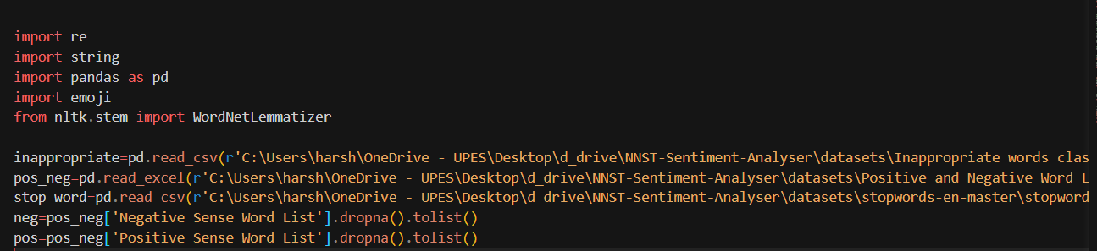

Importing libraries and converting the dataframe to lists for further processing.

Cleaning the vocabulary so that words containing in stop_word shouldn’t be there in the positive and negative word vocabulary.

Lematizer would lematize the word to its root form

Text=input()

Will be taking the input from the user

Demojize would return the meaning of emoji

Further using re (regular expression) for removal of url, hashtags, punctuations, new lines

Checking if the word in the input text is in the stop_word vocab if it doesn then removing it from the sentence as it would not be helping in the sentiment analysis.

Then calculating sentiment for positive or negative by calculating the number of positive or negative words in the sentence and increasing the counter.

Finally predicting the sentence based on the difference of the counts of positive and negative words in the sentence.